Most common :

* AWS
* Microsoft Azure
* Google Cloud Platform (GCP)
* Digital Ocean

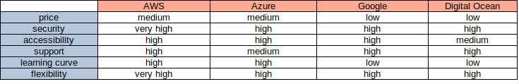

* for low prices we can choose digital ocean or google
* for high flexibility and rich features we can choose AWS
* for easy usage and installation we can choose azure
* digital ocean is very well documented